the top time zones and timings

Timezone Start time (in PST)
MST 15:00:00 68
EST 16:00:00 66
MST 16:00:00 60
EST 15:00:00 57
CST 15:00:00 56
16:00:00 52
EST 14:00:00 44
PST 16:00:00 41
EST 17:00:00 40
13:00:00 39

Top Time Zones for Scheduling Classes:
Timezone
EST 376
MST 332
PST 242
CST 241
IST 136
Not Provided 49
AEDT 36
AST 21
JST 16
WAT 16
GMT 14

Top Timings for Scheduling Classes:
Start time (in PST)
16:00:00 280
15:00:00 272
14:00:00 169
13:00:00 133
17:00:00 125
12:00:00 112
17:30:00 65
18:00:00 51
11:00:00 51
15:30:00 51
12:30:00 49
16:30:00 47
14:30:00 30
13:35:00 23
10:00:00 16
18:15:00 11
11:30:00 8
19:00:00 0

Best Teachers:
Teacher Name
Mary Daniels 3.687500
Melissa Peterson 2.588235
Dana Lorelle 2.466926
Rae Wilson 2.464516
Marcos Del Cogliano 2.370370
Name: Final score, dtype: float64

Best Classes:
Class name
Creative Writing 101 9.000000
Forgotten Histories and Mysteries: The Dancing Plague 5.166667
Draw It: Dolphin 4.944444
Forgotten History: Mysteries and Extraordinary Stories - Egyptian mysteries and riddles 4.416667
Forgotten History: Mysteries and Extraordinary Stories - The Disappearance of Malaysian Flight MH370 4.312500
Name: Final score, dtype: float64

Best Teacher-Class Combinations:
Teacher Name Class name
Annalisa Ard Creative Writing 101 9.000000
Nicole Pauling Forgotten Histories and Mysteries: The Dancing Plague 5.166667
Cara Bailey Draw It: Dolphin 4.944444
Nicole Pauling Forgotten History: Mysteries and Extraordinary Stories - Egyptian mysteries and riddles 4.416667
Forgotten History: Mysteries and Extraordinary Stories - The Disappearance of Malaysian Flight MH370 4.312500
Annalisa Ard History of Magic: Part 1 4.090909
Enchanting Prose: A Magical Writing Workshop with Harry Potter - Part 1 4.000000
Nicole Pauling Forgotten History: Mysteries and Extraordinary Stories - DB Cooper Escape 3.909091
Rae Wilson Middle School Essay Writing Booster 3.875000
Mary Daniels Long Division

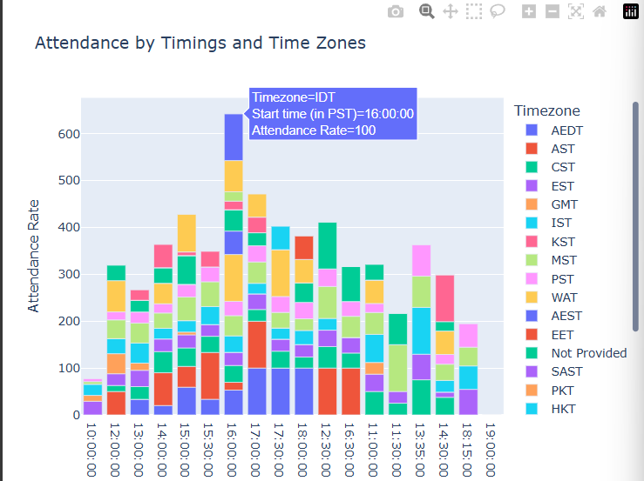

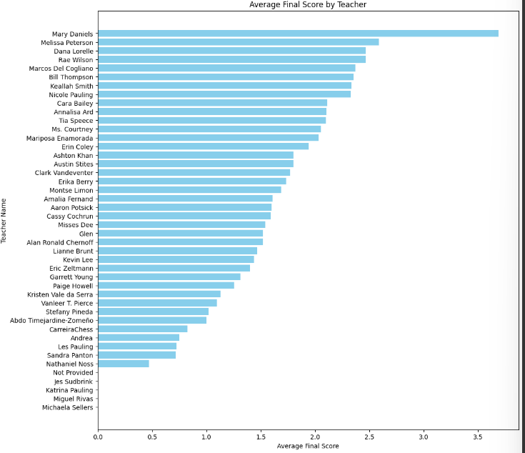

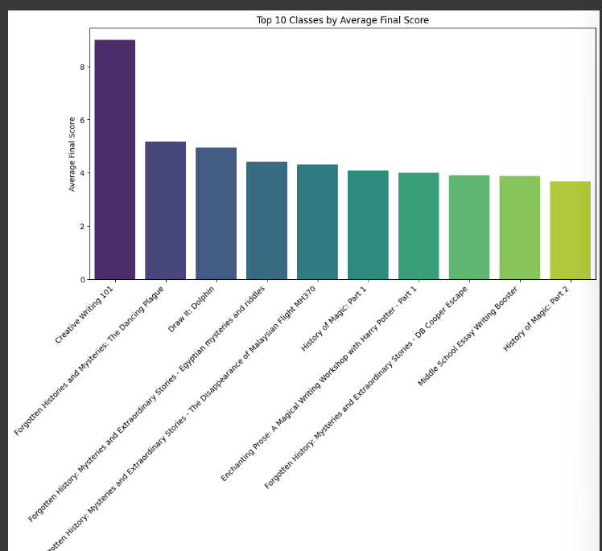
Teachers with most 'Another class' bookings:
Teacher Name
Annalisa Ard 77
Dana Lorelle 63
Aaron Potsick 62
Nicole Pauling 54
Cara Bailey 53
Amalia Fernand 45
Ms. Courtney 45
Misses Dee 44
Erin Coley 37
Rae Wilson 35
Clark Vandeventer 27
Lianne Brunt 25
Paige Howell 24
Kevin Lee 21
Tia Speece 19
Ashton Khan 18
Montse Limon 15
Bill Thompson 14
Austin Stites 13
Keallah Smith 12
Alan Ronald Chernoff 11
Cassy Cochrun 11
Melissa Peterson 9
Kristen Vale da Serra 9
Garrett Young 7
Mariposa Enamorada 6
Courses with most 'Another class' bookings:
Class name
Introduction to Coding with Python 25
The Week In News: A Current Events Discussion Class 25
Introduction to Creative Writing 23
Creative writing 101 23
Long Division 21
..
Basics of Budgeting 1
How to stop a robot uprising - Mathematical Paradoxes 1
An Introduction to Formal Logic 1

might be an Another class' bookings:
Class name
Mind & Matter: Managing Time, Stress & Philosophical Thought 8
Master the Art of Communication 6
Introduction to Coding with Python 5
Long Division 5
Secrets Unveiled Series 4
..
Teachers with the most 'Interesting' responses:
Teacher Name
Annalisa Ard 78
Dana Lorelle 66
Aaron Potsick 63
Nicole Pauling 60
Cara Bailey 52
Misses Dee 50
Ms. Courtney 47
Amalia Fernand 46
Erin Coley 39
Rae Wilson 38
Paige Howell 29
Clark Vandeventer 28
Lianne Brunt 23
Kevin Lee 22
Tia Speece 20
Bill Thompson 19
Montse Limon 19
Ashton Khan 18
Keallah Smith 17
Alan Ronald Chernoff 13
Austin Stites 13
Cassy Cochrun 11
Kristen Vale da Serra 10
Melissa Peterson 10

Courses with the most 'Interesting' responses:
Class name
The Week In News: A Current Events Discussion Class 29
Introduction to Coding with Python 27
Introduction to Creative Writing 24
Creative writing 101 23
Long Division 22

